**CSC 210: LAB 2 (2022/2023 CLASS)**

1. Develop a GUI program that uses a label and button to allow the user toggle the background color from pink to black and vice versa as shown in the diagram below. Choose an appropriate layout manager.

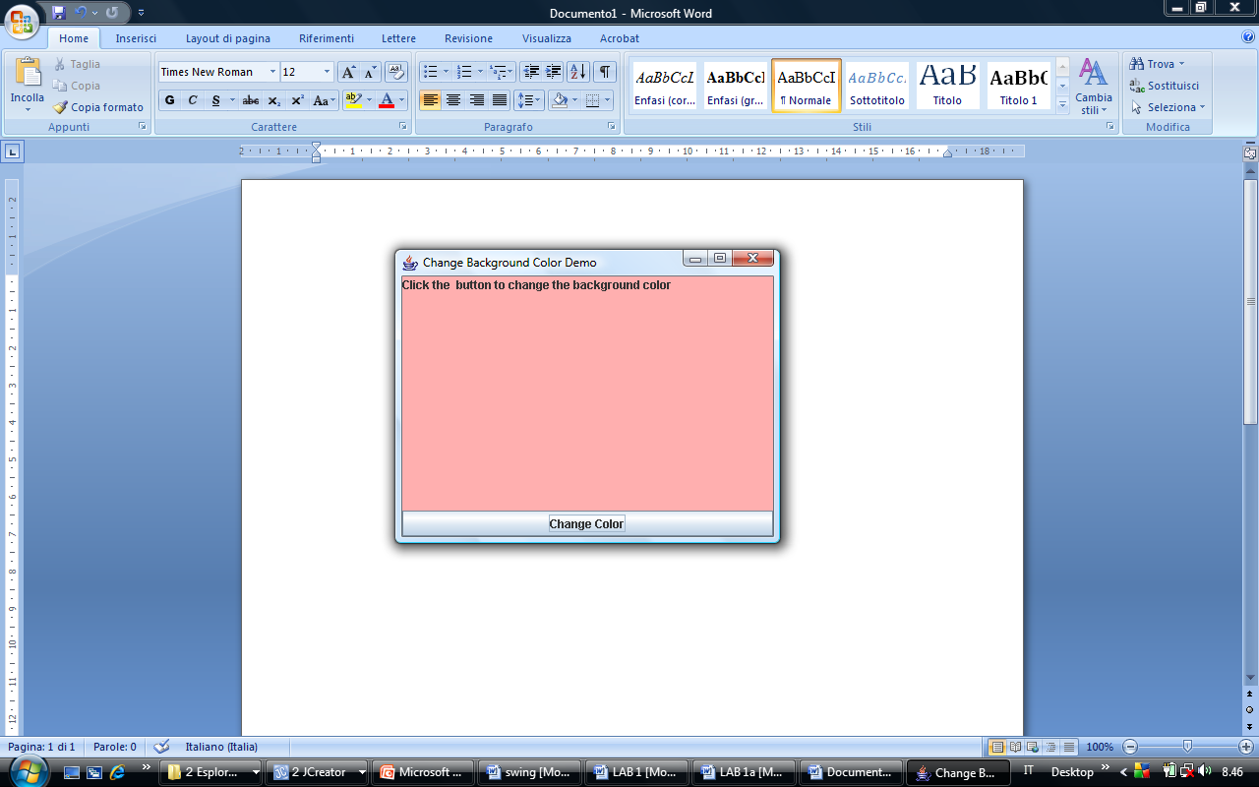

1. Develop a GUI program that displays the colors of the flag of Kenya horizontally. The GUI should have four buttons corresponding to the four flag colors and when a button is clicked the corresponding color should appear. The buttons should be at the bottom of the frame and colored with the Kenyan flag colors. The GUI should have the title: “I love Kenya”.

